**Docker Assignment**

1. Difference between Docker and Podman:

The main difference between both engines is their architecture. Docker CLI depends on a connection to Docker daemon, a program running in background, to create images and run containers, Docker has a client- server logic mediated by a daemon. Podman does not have a daemon, it can run containers under the user starting the container.

Daemons in Docker have root privileges, making them vulnerable to attacks, Podman can run both, root and rootless containers, and containers in Podman do not have root access by default.

1. Create, build and run a container with a Dockerfile:

To start with the exercise, we have a short program in node.js using express, this program listens on port 3000 and only displays a message:

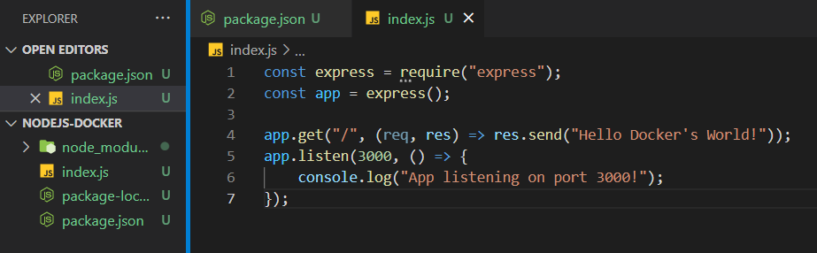

First, we have to add the Dockerfile, we can see the necessary content and the explanation of each line in the next image:

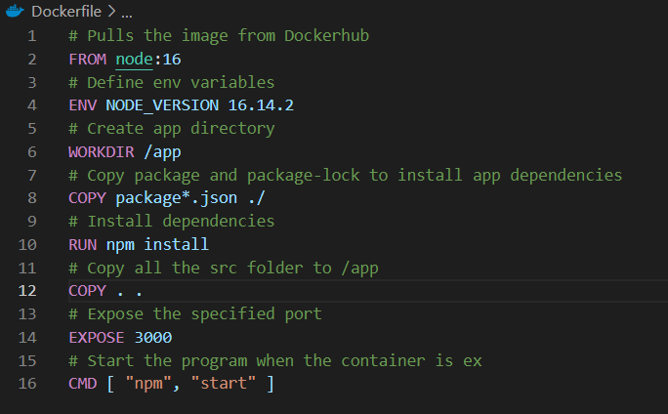

We also create a .dockerignore file to ignore node_modules when we are copying the content of the folder to our container:

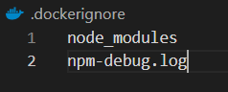

Next we pull the image that we are going to use in our Dockerfile, in this case node:16 with the command docker pull node:16. Then we build our image using the Dockerfile, to achieve this we use the command docker build -t test/nodeserver . , if we were not located in the path where the Dockerfile is we have to specify it, -t option let us choose the tag for the image we are creating and the dot indicates the source path.

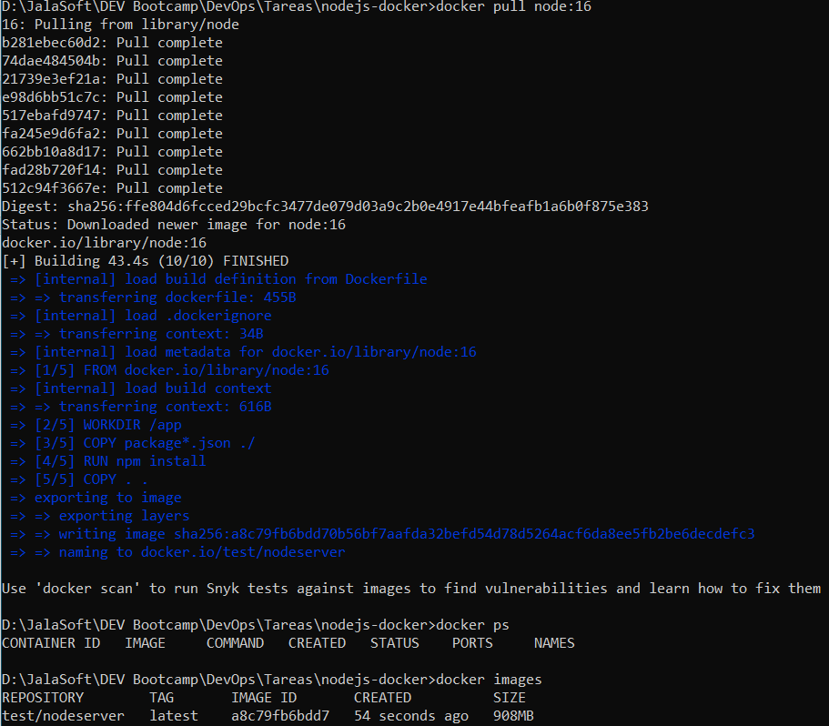

Now that we have the image created, we can run a container using it. We use the command docker run --rm -p 3000:3000 -d test/nodeserver , and also we can see the logs:

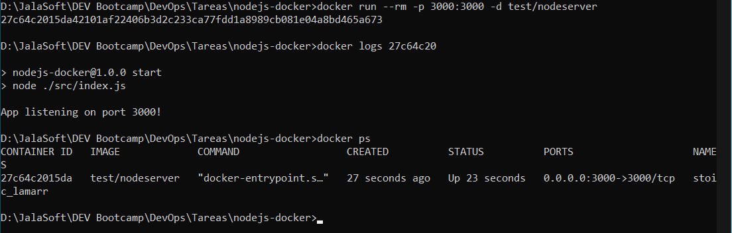

Our program is running:

